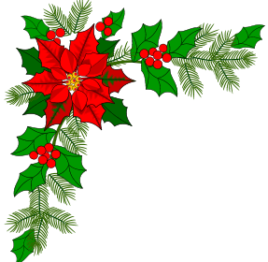
Jingle Jog 2026

Sponsor Application
Race Day: December 12, 2026

Sponsor Name: (as it should appear on printed material: email logo to email below)

______________________________________________________________________________________

Contact Name: _________________________________________________________________________

Address: (City, ST, Zip) ___________________________________________________________________

Phone: ___________________________ Email: _______________________________________________

Sponsorship Level:
Platinum $5000 Gold $1000 Prize $800 T-shirt $600 Bib $500 ____Silver $500
Bag $400 Bronze $250 Water/Snack $250
$ Donation

Applications are due by Nov 30, 2026
Make checks payable to and mail to:
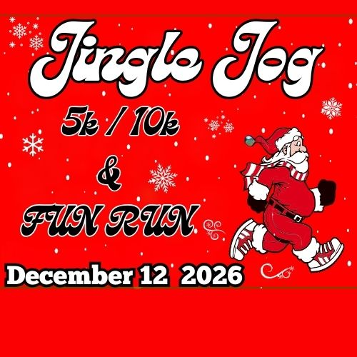
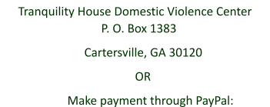
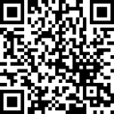

Contact information: communityrc@tranquility-house.org or call 770-386-8093
Jingle Jog Sponsorship Levels 2026

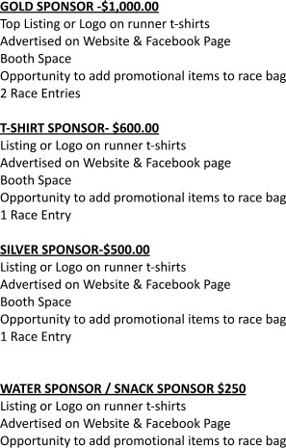
PLATINUM SPONSOR- $5,000.00
Primary Listing or Logo on runner t-shirts Advertised on Website & Facebook Page Prime Booth Space
Opportunity to add promotional items to race bag 4 Race Entries

PRIZE SPONSOR- $800.00
Listing or Logo on runner t-shirts
Assist Race organizer with handing out medals Advertised on Website & Facebook page Booth Space
Opportunity to add promotional items to race bag 1 Race Entry

BIB SPONSOR- $500.00
Listing or Logo on all participants' Bibs. Listing or Logo on runner t-shirts Advertised on Website & Facebook Page Booth Space
Opportunity to add promotional items to race bag 1 Race Entry

BAG SPONSOR $400.00 (1)
Must provide Bags.
Listing or Logo on runner t-shirts Advertised on website & Facebook page
Opportunity to add promotional items to race bag

BRONZE SPONSOR- $250.00
Listing on runner t-shirts
Advertised on Website & Facebook Page Opportunity to add promotional items to race bag


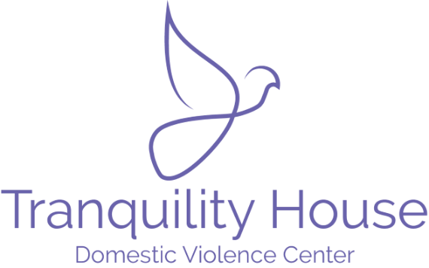

For all sponsorships that have a race entry, please submit the runners name and t-shirt size by Nov.30, 2026 to communityrc@tranquility-house.org.
Proceeds to benefit:

