Costume Contest-
Individual, Team and Pet.
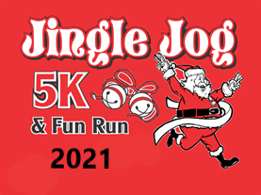
Free Jingle Bells
& T-shirts for
Participants

December 11, 2021
Sam Smith Park~ Cartersville Soccer Complex

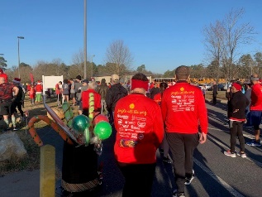
8:00am Race Day Registration
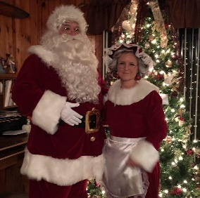
9:00am 5K – chipped timing
9:45am Holiday Hustle~ 1mile Run/Walk
10:00am “Dasher Dash” (5 and under free)
10:15am Awards Ceremony
(Overall winners & all age groups)
Meet Mr. & Mrs. Claus
5K: $25 Pre-registration until December 1st
$35 Race Day
Holiday Hustle Fun Run/Walk $15 Pre-registration until December 1st
$25 Race Day

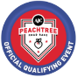
Register & Pay online- www.wire2wirerunning.com/race-calendar

